Nicole Hilden

SSW-567

Homework 1

September 1, 2018

I pledge my honor that I have abided by the Stevens Honor System

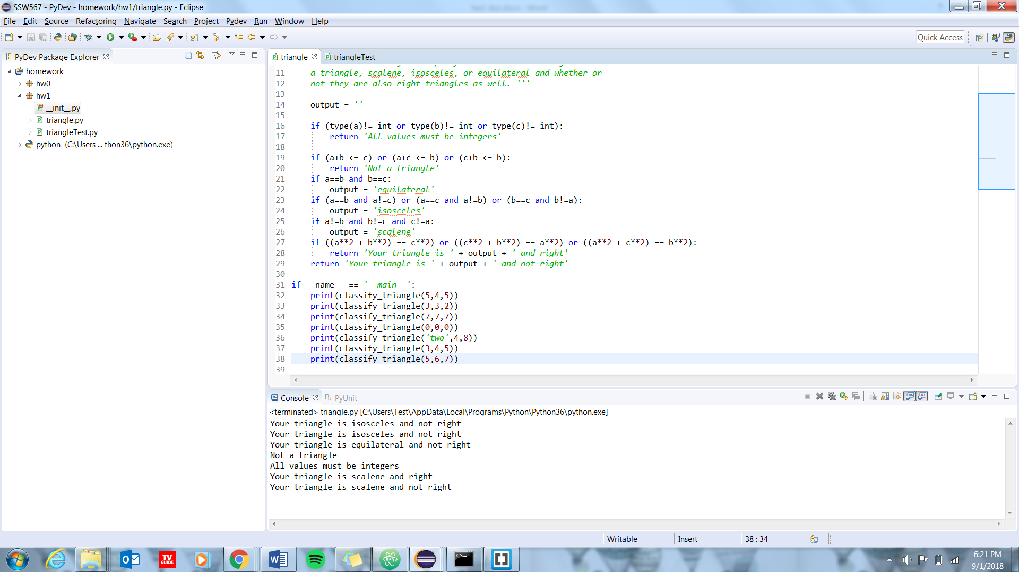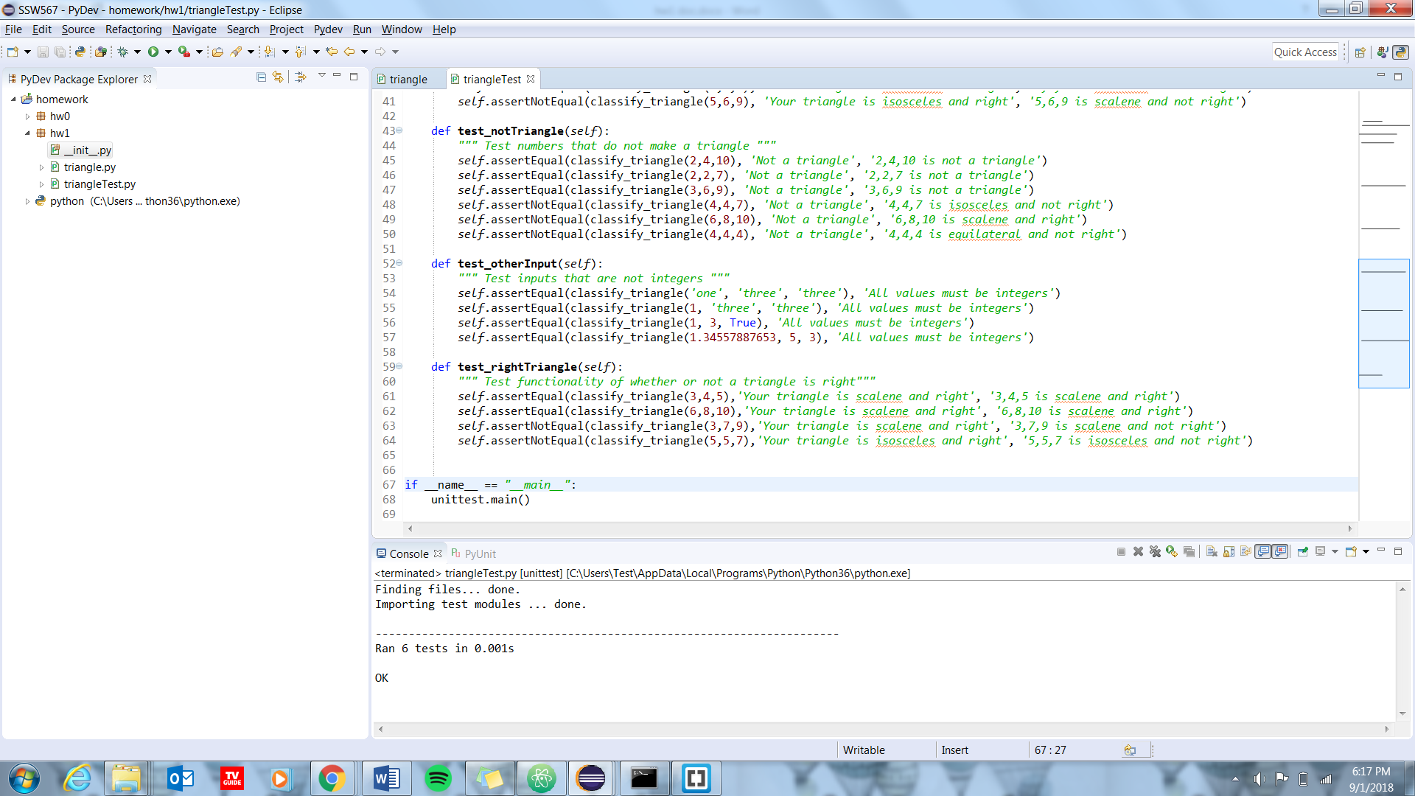Deliverable 2:

Deliverable 3:

* What challenges did you encounter with this assignment, if any?
  + In this assignment, the main challenge that I faced was when I was creating the test cases for my triangle method. I had a hard time determining at what point I was confident that the test cases I created provided full and complete coverage of my classify_triangle method.
* What did you think about the requirements specification for this assignment?
  + I thought that the requirements served to give us a good general idea of how to create the assignment. I felt that maybe as the first assignment it would have be slightly more helpful to have provided an expectation of approximately how long the test script should be.
* What challenges did you encounter with the tools?
  + I did not really encounter any problems with either python or unittest. I just had to refresh my memory on some of the python syntax.
* Describe the criteria you used to determine that you had sufficient test cases, i.e. how did you know you were done?
  + I made sure that I had a test block for each scenario: scalene, equilateral, isosceles, right, not a triangle, and other inputs. And within each block I tested a couple of different assertEqual to confirm that my program classifies the triangles correctly and I also included a couple of assertNotEqual to test scenarios that should not been correct

Deliverable 4:

<https://github.com/nhilden1114/567-hw1>